Turnkey has been busy for the last 14 months developing solutions to simplify our dealer’s administrative loads! We come from a dealer background and understand the relevance of having continuity between what your showroom looks like and how it is displayed online! Of course, we are also aware that maintaining a DMS System, Website and Marketplaces where you display your information is a laborious task especially when you consider changes or new inventory uploads to your DMS, Website and Marketplaces multiple times per day! We have some time saving solutions which have been developed to minimize administrative time and maintain continuity. Customers can find you in many places, so it is always best practice to display all of what you have on all platforms your using. Our time saving bolt on solutions are DMS Integration, 3PI Integration and Ecommerce! Our Mobile App and Web Editor have been updated and will be released in January 2020. For more information on these exciting new developments click on the links below or reach out to us and **book a demo**!

1. Turnkey DMS Integration
2. Turnkey 3PI Syndication
3. Turnkey Mobile App
4. Turnkey Web Editor 5.0
5. Turnkey Ecommerce Solution

Let’s work together to manage a great Online presence and give you the time to get back to what you are best at! Selling!

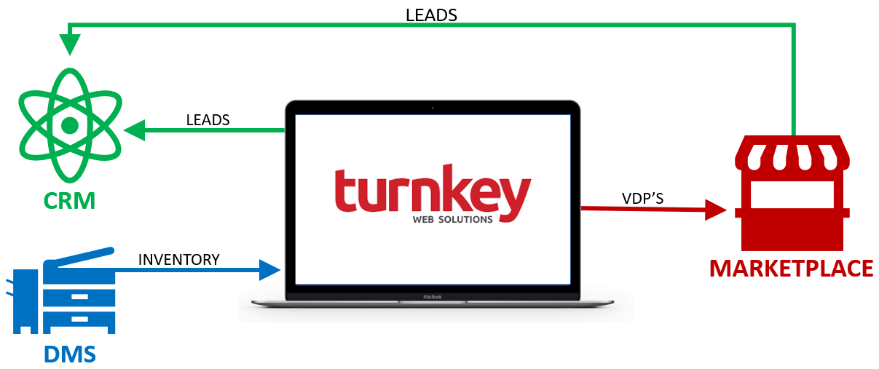**Book A Demo Today**!